“Modeling the Relationship between the Distribution of Acer saccharum (Sugar Maple) and
Climate Variables Using WorldClim Data”.

DSE6311: Data Science Capstone
Trinity Tobin

Introduction
My research question is modeling how climate variables related to temperature and precipitation impact the distribution of the sugar maple (Acer saccharum) across North America. I hypothesize that the abundance of sugar maples will be effectively detected through the use of predictive modeling and climate data because shifts due to climate change are gradual. My prediction is that predictive models can be effectively created with the use of WorldClim bioclimatic variables and time-lagged variables derived from GBIF data. With both data sets chosen, exploratory data analysis can allow for preliminary summary statistics and the formulation of a robust analysis plan to answer the proposed research question.

Methods
There are two data sets I will be utilizing. The first data set consists of the WorldClim bioclimatic variables, which is a set of 19 variables depicting various meteorological conditions related to temperature and precipitation. The focus of the exploratory data analysis was on six of the variables linked to temperature and precipitation (Figure 1). The second data set is a set of GBIF (Global Biodiversity Information Facility) occurrences of sugar maples extending back from 1850 to present, with these occurrences centralized on the East Coast of the United States, extending up into Canada (Figure 2).
The preliminary GBIF data was cleaned and formatted in Excel before the data analysis began. These two data sets were joined together to create one data set containing the coordinates and the date (year) of each occurrence, which was then used to calculate the abundance of the sugar maple in a given area.
Exploratory data analysis was conducted through the creation of summary statistics and visualization techniques. The climatic variables were summarized both through summary statistics (Table 1) and histograms, with both depictions showcasing the spread of the data. The GBIF variables were summarized through the use of line graphs to explore spatial-temporal relationships between year, precipitation, and temperature (Figures 5 & 6), as well as summary statistics to explore the derived variable of abundance.
Additional methods were used to process the data for exploratory analysis. The variable of abundance was created and characterized by the average amount of occurrences based on state. Other derived variables may be created during preprocessing but as abundance is a target for the modeling, it was important to define and analyze it during this phase. Overall, these methods allow for analysis of relevant patterns in the data, multicollinearity, and possible feature selection and model decision-making.

Results (Tables, Visualizations, and Brief Interpretations)
The first set of figures explored the distribution of the WorldClim variables. Figure 1 shows the distribution of the six chosen variables across North America. When combined with the sugar maple occurrences in Figure 2, we see that sugar maples are concentrated on the Eastern side of the United States, stretching up and down the coast and into parts of southeastern Canada (Figure 2).

Strong positive correlations are observed between temperature-related variables, particularly BIO1 (Annual Mean Temperature) and BIO5 (Maximum Temperature of the Warmest Month), while precipitation variables such as BIO12 (Annual Precipitation) and BIO16 (Precipitation of the Wettest Quarter) also show a strong positive relationship. Negative correlations are evident between temperature seasonality (BIO4) and several other variables, highlighting potential multicollinearity that should be considered in subsequent modeling.

Discussion & Next Steps
The exploratory data analysis revealed substantial variability and multicollinearity within the WorldClim variables. The skew of the variables in the histograms shows that there is an uneven distribution of climatic conditions, which is reasonable given the scope of North American climate conditions (Figure 3). The correlation analysis showed that many of the climatic variables are highly correlated, which will need to be controlled for when preprocessing and with regularization when creating models (Figure 4).
The findings derived from this analysis show that climate conditions are playing a role in species distribution, which supports my research question. The differences in climate conditions between sugar maple abundant locations supports the conclusion that there are preferred environmental ranges for the species (a trend clearly seen in Figure 2). This further aligns with my hypothesis that temperature and precipitation both drive species patterns and are affected by climate change.
Moving forward, the project will continue with preprocessing of the data. In maintaining a robust analysis and data set, the remaining 13 WorldClim variables will be analyzed for multicollinearity and added to exploratory analysis. To create time-lagged variables in accordance with my current abundance variable, the abundance by state will be divided among longitudinal lines to create “abundance slices” of the Earth for where the sugar maple is most likely to be present. My baseline model will be a linear regression model, which will be used to further explore the primary causes of species distribution in varying climatic conditions.

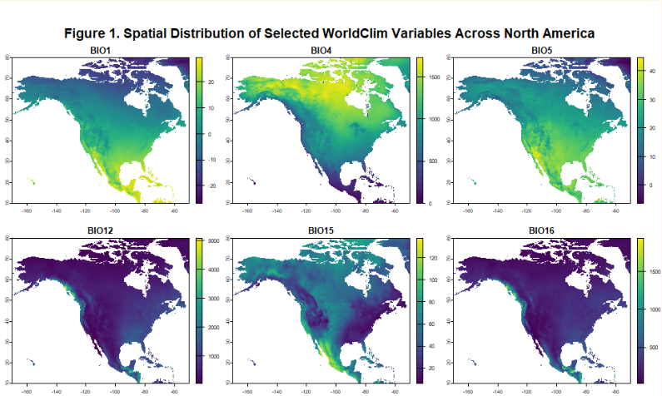
Figure 1. Spatial distribution of selected WorldClim variables across North America. BIO1 = Annual Mean Temperature, BIO4 = Temperature Seasonality, BIO5 = Maximum Temperature of Warmest Month, BIO12 = Annual Precipitation, BIO15 = Precipitation Seasonality, and BIO16 = Minimum Temperature of Coldest Month. These maps show the range of temperature and precipitation patterns that could be impacting the distribution of the sugar maple.
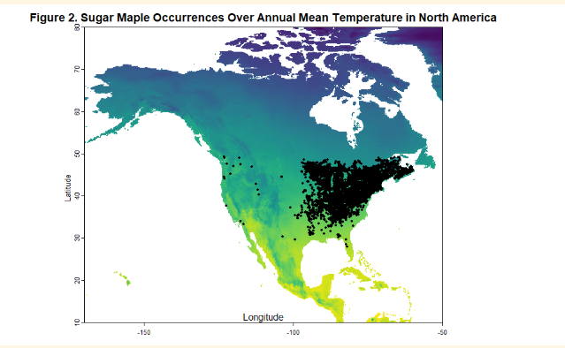Figure 2. Sugar maple occurrence records overlaid on the BIO1 raster layer (Annual Mean Temperature) across North America. The background-colored map represents temperature, with lighter colors indicating warmer temperatures and darker colors indicating cooler temperatures. Black points represent GBIF observations of sugar maple. The figure shows that sugar maple occurrences are concentrated in regions with moderate temperature conditions, particularly in the northeastern United States and Canada.

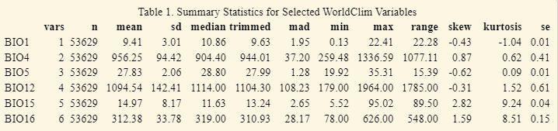
Table 1. Summary statistics for my selected WorldClim bioclimatic variables across all sugar maple locations. The variables include BIO1 (Annual Mean Temperature), BIO4 (Temperature Seasonality; standard deviation ×100), BIO5 (Maximum Temperature of the Warmest Month), BIO12 (Annual Precipitation), BIO15 (Precipitation Seasonality; coefficient of variation), and BIO16 mean is the average value, sd is the standard deviation indicating variability, median is the midpoint of the distribution, trimmed is the mean after removing extreme values, mad is the median absolute deviation (a robust measure of spread), min and max represent the top and bottom values of the range, range is the difference between minimum and maximum values, skew indicates asymmetry of the distribution, kurtosis reflects the presence of outliers or tail heaviness, and se is the standard error of the mean. These statistics summarize the temperature and precipitation conditions associated with sugar maple occurrences across North America.
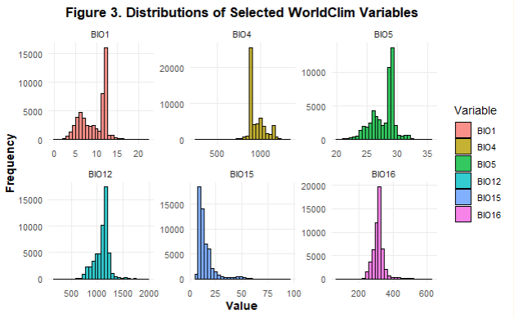
Figure 3. Distributions of selected WorldClim bioclimatic variables for sugar maples. Histograms show the frequency distributions for BIO1 (Annual Mean Temperature), BIO4 (Temperature Seasonality), BIO5 (Maximum Temperature of the Warmest Month), BIO12 (Annual Precipitation), BIO15 (Precipitation Seasonality), and BIO16 (Precipitation of the Wettest Quarter). These plots summarize the range and shape of the climatic conditions associated with sugar maple observations.

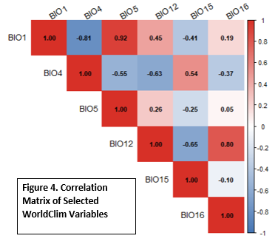
Figure 4. Correlation matrix of selected WorldClim bioclimatic variables across sugar maple occurrence locations. Values represent Pearson correlation coefficients, with warmer colors (red) indicating positive relationships and cooler colors (blue) indicating negative relationships.

Strong positive correlations are observed between temperature-related variables, particularly BIO1 (Annual Mean Temperature) and BIO5 (Maximum Temperature of the Warmest Month), while precipitation variables such as BIO12 (Annual Precipitation) and BIO16 (Precipitation of the Wettest Quarter) also show a strong positive relationship. Negative correlations are evident between temperature seasonality (BIO4) and several other variables, highlighting potential multicollinearity that should be considered in subsequent modeling.

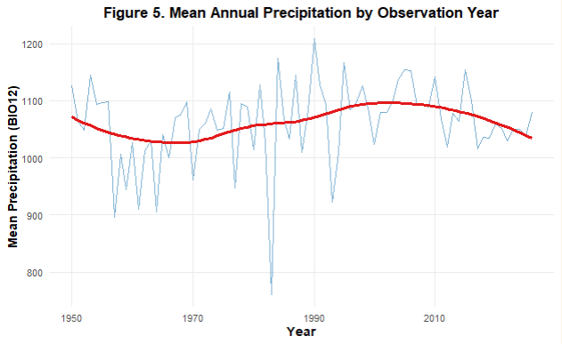
Figure 5. Mean annual precipitation (BIO12) across sugar maple occurrence records by observation year. A smoothed trend line is included to highlight overall patterns.
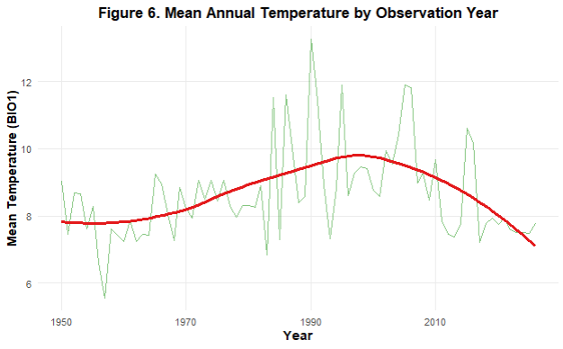
Figure 6. Mean annual temperature (BIO1) across sugar maple occurrence records by observation year. The smoothed trend line illustrates general variation over time.

Table 2. Spatial distribution summary of sugar maple occurrence records across North America. Total abundance represents the total number of cleaned GBIF occurrence points, while average abundance reflects the mean number of occurrences per state or region. Minimum and maximum latitude and longitude values define the geographic boundaries of the dataset.

Appendix
LINK TO GITHUB REPO: https://github.com/trini-png/DataScienceCapstone

